Test Plan for Charity Database Application

Introduction
This test plan will go through my testing strategy and the expected results for my database application. Ensuring that all my operations for donors, events, donations and all entities function correctly

Test 1: Adding Donor
This test ensures that a new donor can be successfully added. You must run the application, select Add Donor, Enter the necessary information then press Enter to save it.
Expected results: The donor is successfully added to the database
Actual Results:
Figure 1: Python
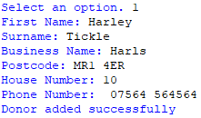
Figure 2: DBBrowser
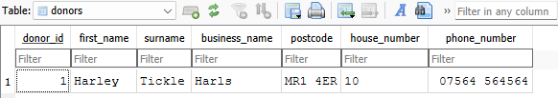
As shown by my test, the donor was added and details shown in DBBrowser.

Test 2: View all Donors
This test ensures that users are able to view all donors inside of the database, you do this by running the application, selecting manage donors, then selecting view donors.
Expected results: The python displays all existing donor information
Actual Results:
Figure 3: View all donors
I created an additional record to show that all information is provided for all existing donors.

Test 3: Updating Donor Information
This test is used to ensure donor information can be updated correctly and successfully. This is done by navigating to the update donor option
Expected results: the donor information updates correctly.
Actual results:
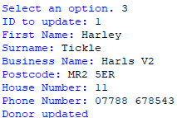
Figure 4: Successful Donor Information Update
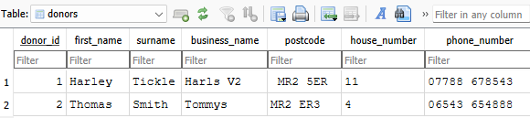
Figure 5: DBBrowser
As shown in Figure 5, the information has been successfully updated with an updated business name, postcode, house number and phone number.

Test 4: Deleting a donor without donations
This test is to ensure that a donor without donations can be deleted
Expected results: donor is deleted due to not meeting the requirements
Actual results:
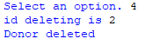
Figure 6: Deletion of ID
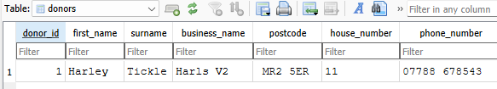
Figure 7:Donor no longer here
As shown in DBBrowser, there is no longer a Thomas Smith as no donation was made under that ID.

Test 5: Deleting a donor with donations
This test is to ensure that a donor with donations cannot be deleted
Expected results: donor is not deleted due to meeting the requirements
Actual results:
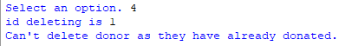
Figure 8:Deletion not made
As shown in figure 8, the deletion could not be made because Harley has made a donation

Test 6: Adding Event
This test is to ensure that an event can be added
Expected results: event is successfully added

Actual results:
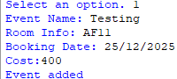
Figure 9:Idle
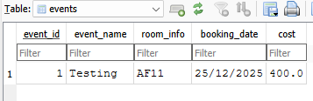
Figure 10:DBBrowser
As shown in figure 10, the event was successfully added.

Test 7: Viewing all events
This test is to ensure that all events are correctly presented and viewed
Expected results: all events display all information correctly.
Actual results:
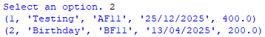
Figure 11: Viewing events in idle
As shown in figure 11, the events are being presented perfectly.

Test 8: Deleting event without donations
This test is to ensure that events which have no donations can be deleted.
Expected results: all events with no donations are deleted.
Actual results:
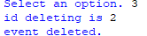
Figure 12: Event is deleted
As shown in figure 12, the event is deleted as no donations have been made from them.

Test 9: Deleting event with donations
This test is to ensure that events which have donations cannot be deleted.
Expected results: all events with donations are not deleted.
Actual results:
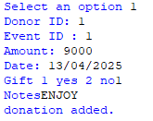
Figure 13: Donation made by EventID 1
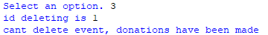
Figure 14: Event not deleted
As shown in Figure 14, this event cannot be deleted because it has previously made donations.

Test 10: Add donation
This test is to ensure that donations can be successfully added.
Expected results: all donations are correctly added.
Actual results:
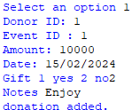
Figure 15: Donation Successfully Added
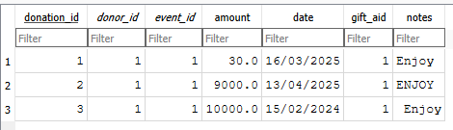
Figure 16: DBBrowser
As shown in figure 15, this donation and previous ones were successfully added and correctly shown.

